SOFTWARE ENGINEERING LAB EXPERIMENTS

CSA1012 - Software Engineering Name: N. Sri Balaji
Jira Lab Experiment Reg.No:192525275

Experiment 1
- Create a Kanban Board to Visualize the Tasks.
  - Create Columns for To Do, In-Progress and Done.
  - Add Atleast 5 Sample Tasks
  - Move the Tasks across the Columns to Simulate the Workflow.
- 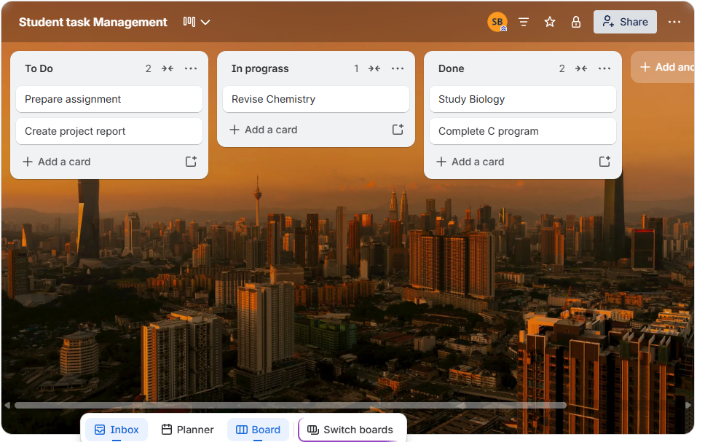

SOFTWARE ENGINEERING LAB EXPERIMENTS

Experiment 2

- Sketch a Simple Prototype of a Bus Ticket Booking System using Figma Tool
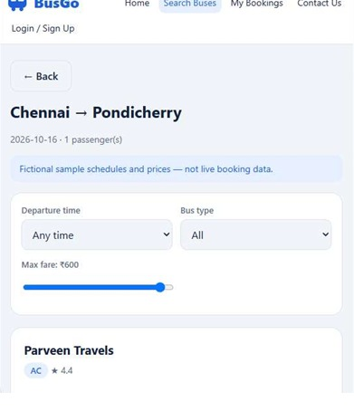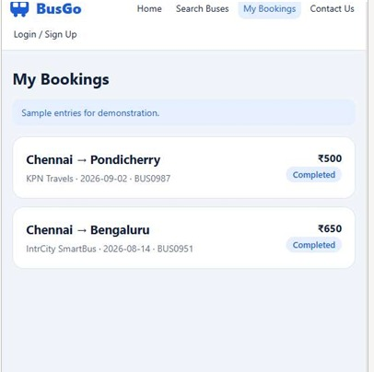

SOFTWARE ENGINEERING LAB EXPERIMENTS
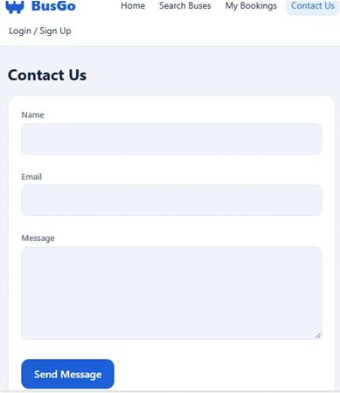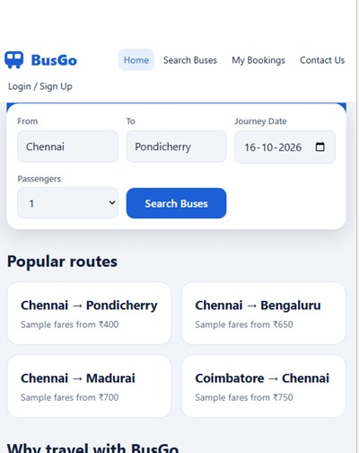

SOFTWARE ENGINEERING LAB EXPERIMENTS
Experiment 3
- The stakeholders have conflicting views on the user interface design for an E-Commerce mobile app. Create a prototype using Figma tool to discuss with the stakeholders to get their feedback and approval.

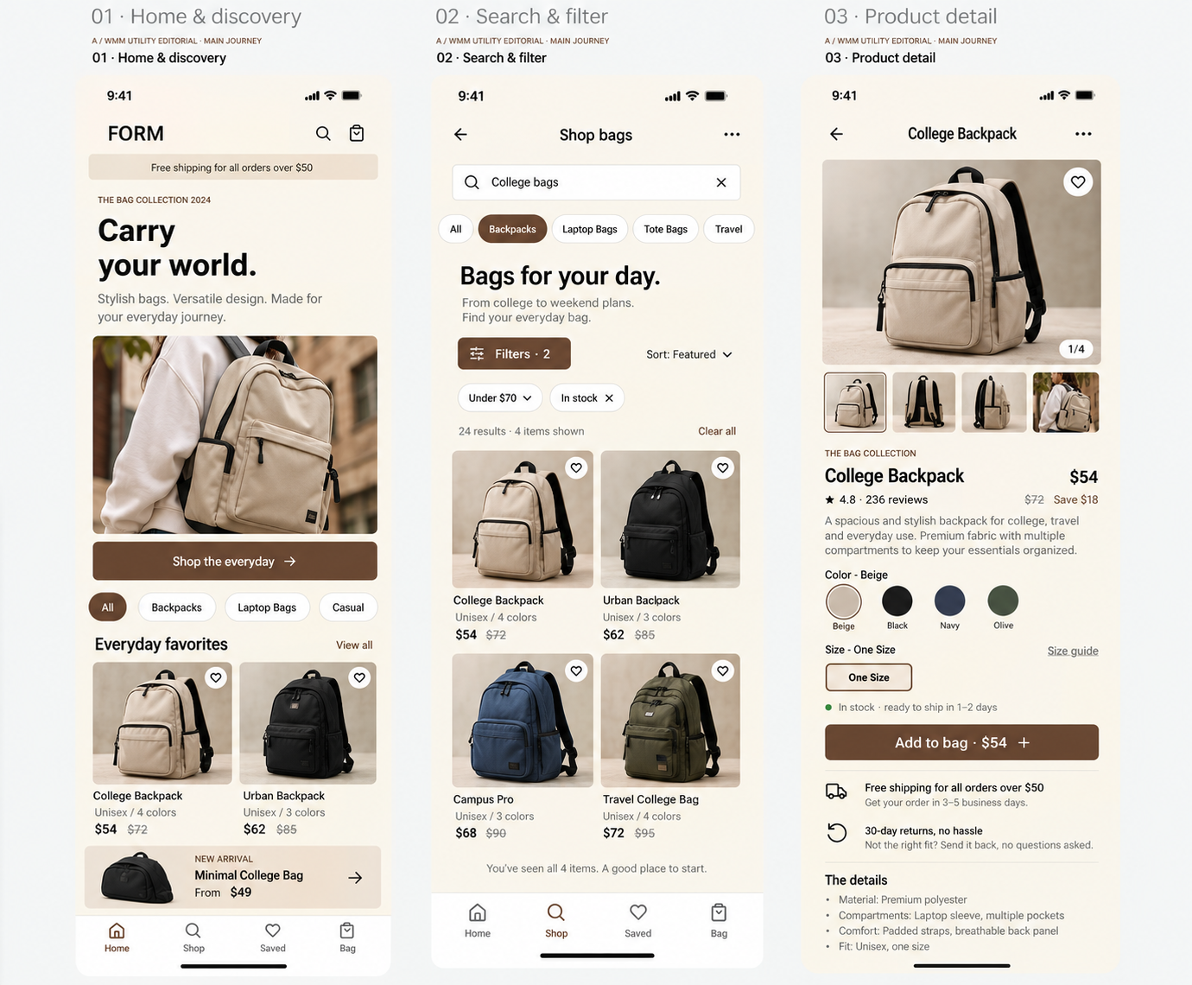
SOFTWARE ENGINEERING LAB EXPERIMENTS

SOFTWARE ENGINEERING LAB EXPERIMENTS
Experiment 4
- Create a Scrum Project in Jira.
  - Add a backlog with at least 5 items (e.g., "Create user
  - registration page", "Develop API for login").
  - Prioritize the backlog and create a 1-week sprint.
  - Move backlog items into the sprint and start the sprint.
  - Finally show the Screenshot
- 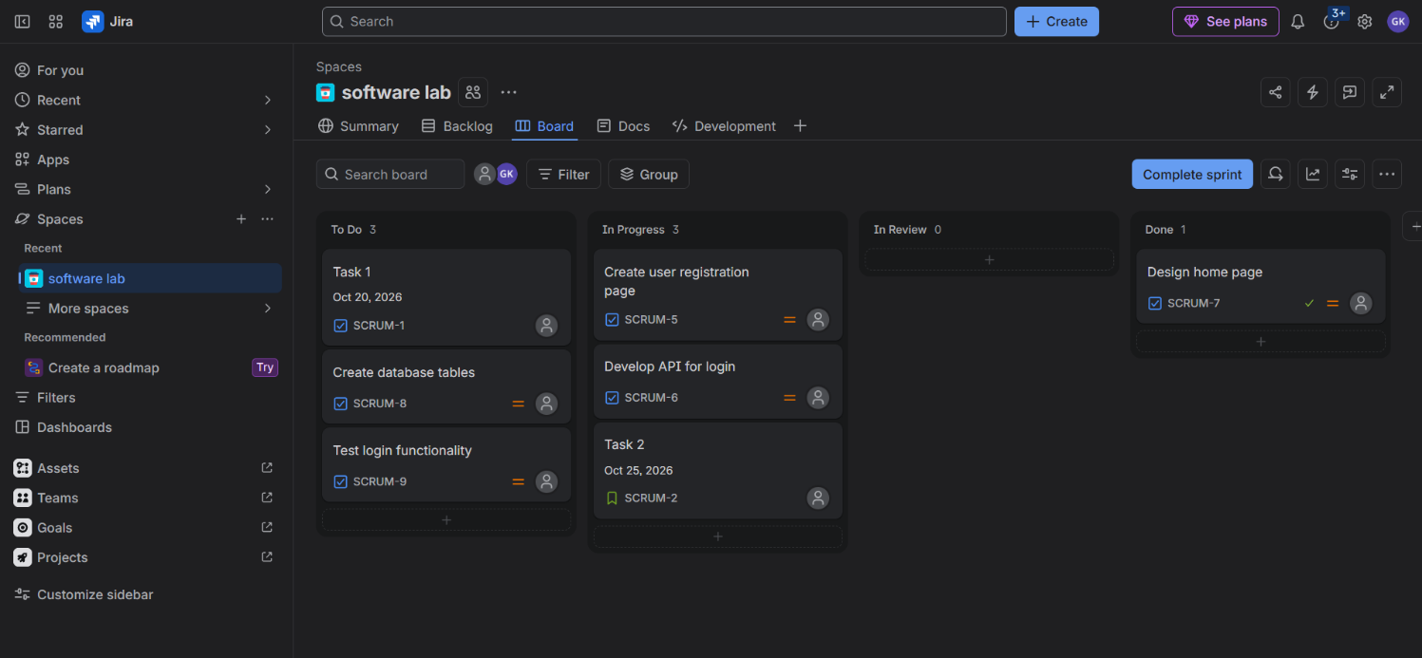
- 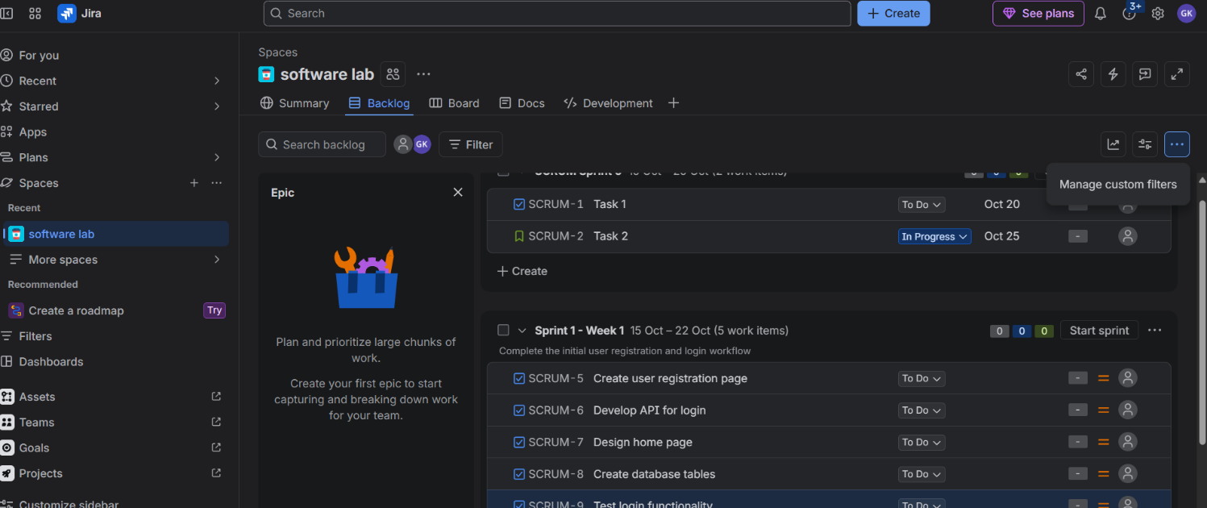

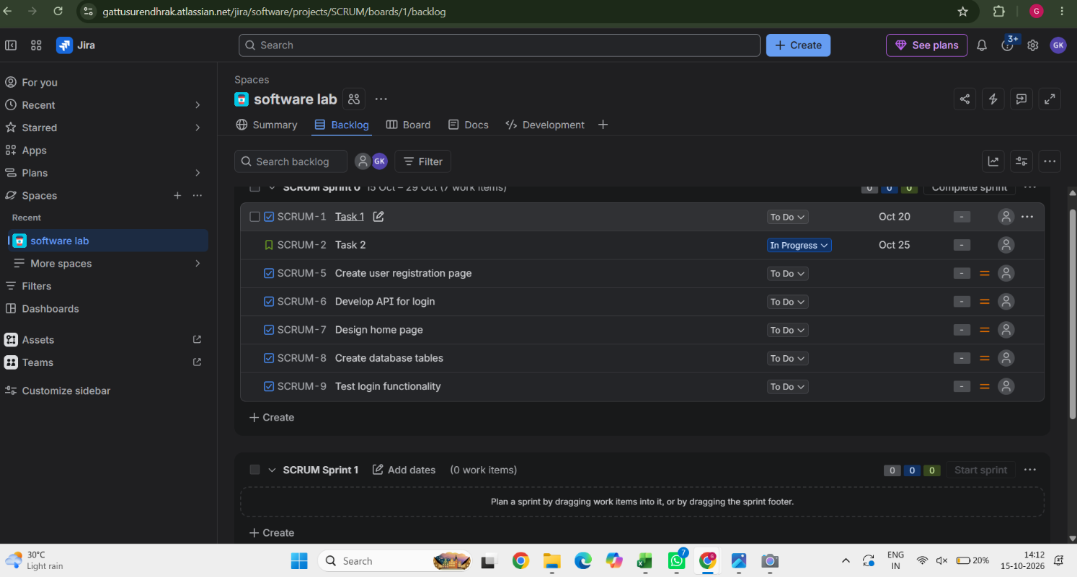

SOFTWARE ENGINEERING LAB EXPERIMENTS
SOFTWARE ENGINEERING LAB EXPERIMENTS
Experiment 5
- Use the following requirements for a Library Management System:
  - Add a feature to search books by title and author.
  - Implement an online book reservation system.
  - Generate monthly reports on borrowed books for
  - administrators.
  - Enable email notifications for overdue books.
  - Add support for QR code scanning for borrowing and
  - returning books.
  - Create a user-friendly dashboard for librarians.
  - Allow users to review and rate books.
  - Integrate a chatbot for user assistance.
  - Develop a mobile app version of the system.
  - Provide multi-language support.
  - Categorize each requirement using MOSCOW Method (Must-Have,
  - Should-Have, Could-Have, or Won’t-Have) based on the following
  - criteria:
  - Impact on the users and stakeholders.
  - Feasibility considering time, budget, and resource constraints.
  - Finally Submit the completed Google Sheet or Excel file with all

  - requirements categorized and justified.

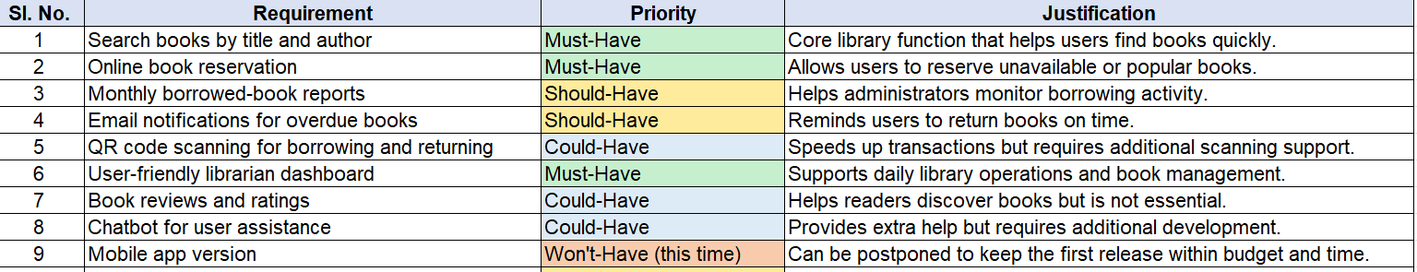

SOFTWARE ENGINEERING LAB EXPERIMENTS

Git Hub Link: https://github.com/Balu21-cell/CSA1012.git

SOFTWARE ENGINEERING LAB EXPERIMENTS

